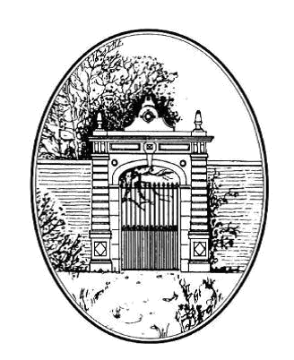
Cambridgeshire
gardens trust

SMALL GRANTS SCHEME APPLICATION FORM

- Name of the project:

- Organisation or person making the application:

- Is the organisation a registered charity? YES / NO

If yes, please give charity number

- Name, address and postcode of the person making this application:
Name of applicant
Address
Post code
Tel. number
Email address

- Description of the project and maintenance plan, where applicable (1,000 words max)

- How will this project help to achieve Cambridgeshire Gardens Trust’s objects? (See guidance notes)

- Who will benefit from this project?

- How will the applicant monitor the success of the project?

- Proposed start date of the project:

- Anticipated completion date of the project:

- Cost of project, please give the total cost, the cost breakdown and the amount you are applying for. (NB Maximum grant is £500.)

Total cost
Cost breakdown
Amount requested

- Has any other funding been applied for or granted for this project? YES / NO

If so, how much and from whom:

- Is Planning Consent needed for this project? (This might include Listed Building Consent or Scheduled Monument Consent. Tree works within Conservation Areas also require consent.) YES / NO

If so please enclose a copy, or copies, of any consent obtained

Project representative’s signature:

Date:

We have two grant rounds per year. Applications must be submitted by 30th June or 31st December. Applicants will be notified by the end of the next months (July or January).

Send application form to: admin@cambridgeshiregardenstrust.org.uk

