CAMBRIDGESHIRE GROUP
The Max Walters Memorial Lecture
Plants in my Best Garden Designs
Bunny Guinness
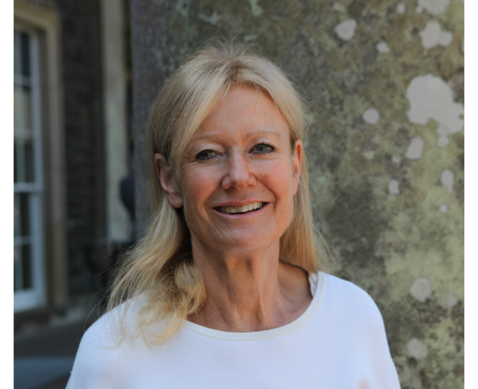
Award winning Landscape Architect with six Chelsea Flower Show Gold Medals & Regular Panellist BBC Radio 4’s Gardeners Question Time

Saturday 9th November 2024
2:00pm for 2.30pm

The William Collyn Centre, Wellbrook Way, Girton, Cambridge CB3 0GP

Tickets (in advance only) £12 for Plant Heritage Members £17 for Visitors
Contact Rosemary Buisseret email: ppsrjb@gmail.com for application form and enquiries.
Ample free parking Disabled Parking available Registered Charity Number 1004009

Ticket Application Form
To be completed and returned to ppsrjb@gmail.com

I wish to purchase ……………… Member’s or Horticultural Student’s Tickets at £12 each
and/or .......... Visitors Tickets at £17 each
Plant Heritage Membership No. / Nos. ………………………………………………………..
Current Place of Study ………………………….………………………………………………..
Name(s)* ………………………………………………………………………………………….
Email (to send email ticket and details of BACS payment)
………………………………………………………………………………………………………..
Phone No ………………………………………………… (in case of sudden change of plans)
* If you are purchasing extra tickets for someone else, please give their names as well.
BACS payment details will be sent with confirmation of receipt of your ticket application
For those wishing to pay by cheque and/or receive a printed ticket - cheques payable to ‘Plant Heritage - Cambs Group’ should be sent with a stamped and addressed envelope to Plant Heritage, 7 Old Glebe, Alconbury, Huntingdon , PE28 4EA

Registered Charity Number 1004009

